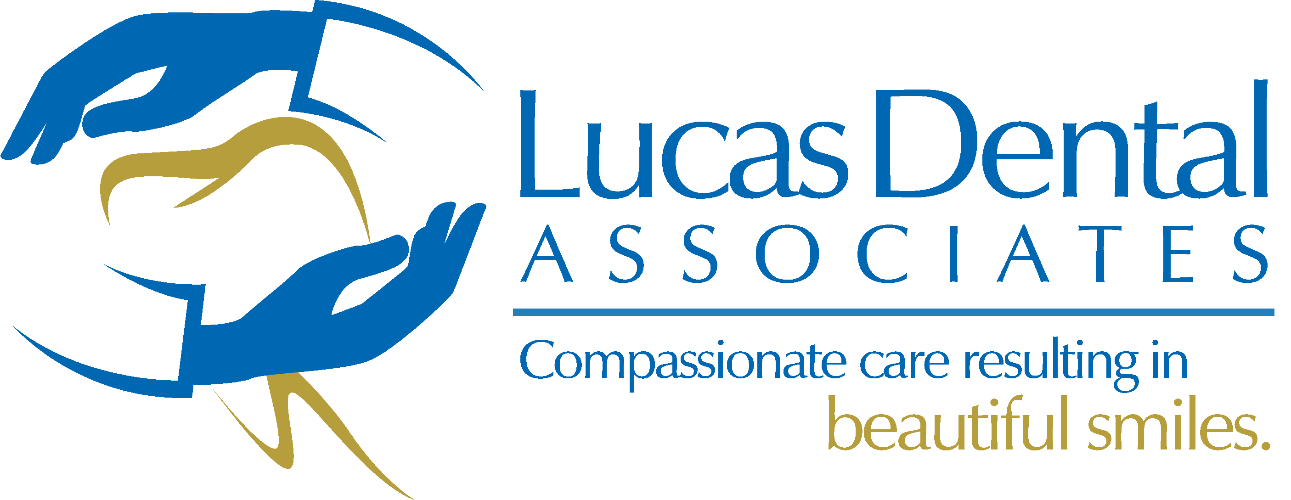
Patient Advisory and Acknowledgment
Receiving Dental Treatment during the COVID-19 Pandemic
Dear Patient: You have come to our office today for an Urgent and/or a Routine Dental Evaluation/Treatment that will be done during the COVID-19 pandemic. Please be advised of the following:
While our office complies with State Health Department and the Centers for Disease Control and Prevention infection control guidelines to prevent the spread of the COVID-19 virus, we cannot make any guarantees.
Our staff members are symptom-free and, to the best of their knowledge, do not have the viral infection. However, since we are a place of public accommodation, other persons (including other patients) could be infected, with or without their knowledge. In order to reduce the risk of spreading COVID-19, we have asked you a number of “screening” questions below. For the safety of our staff, other patients, and yourself, please be truthful and candid in your answers.
Patient name: ___________________________________ Date: ___________________
PLEASE ANSWER YES or NO WITH YOUR INTIALS, TO THE FOLLOWING QUESTIONS:
HAVE YOU BEEN DIAGNOSED POSITIVE FOR THE COVID-19 VIRUS AT ANY TIME ___ YES ___ NO
IF YES HOW LONG AGO __________________________________________________________________
HAVE YOU RETESTED NEGATIVE? ___YES____NO
ARE YOU CURRENTLY AWAITING THE RESULTS OF A COVID-19 TEST? ___ YES ___ NO
HAVE YOU RECEIVD THE ANTIBODY TEST ___YES____NO
WHAT WAS THE RESULT OF THE ANTIBODY TEST ___POS____NEG
CIRCLE ANY SYMPTOMS THAT APPLY TO YOU:
DO YOU HAVE A FEVER, SHORTNESS OF BREATH, DRY COUGH, RUNNY NOSE, SORE THROAT, SNEEZING, WATERY EYES , SINUS PAIN OR PRESSURE, HEADACHES, FATIGUE OR WEAKNESS, LOST YOUR SENSE OF TASTE AND SMELL?
AFTERT TODAY’S VISIT PLEASE REPORT ANY SIGNS OR SYMPTOMS OF COVID 19 WITHIN THE NEXT 14 DAYS TO OUR OFFICE
Patient/Guardian Electronic Signature ______________________________________________________________

